Impact Study of First Year Service Learning Program

Analysis of survey of the impact of Service Learning projects on students and teachers of leading Catholic Schools in Lahore

The survey involves the 6 leading Catholic schools in Lahore in which Service Learning projects were implemented with the assistance of Youth Engagement Services (YES) Network Pakistan in 2009. It was for the first time in the history of Pakistan that Service Learning projects were implemented in 11 Catholic schools. Out of the 11 schools, 6 schools have been chosen in which the service learning projects have been completed. Over 100 Service Learning Projects have been completed in these schools. These projects were related to all fields of life such as health, plantation, raising awareness, reducing pollution, saving natural resources, etc. In the rest of the schools, the Service Learning Projects are still in progress. A sample of 357 students and 66 teachers which were involved in these projects has been chosen from 6 schools. Hence, Stratified Random Sampling has been used for this purpose. Questionnaires were distributed among students and teachers of these schools. Close ended questionnaire were used for this purpose. The survey was conducted to know the effects of the Service Learning Projects upon the students and teachers. It evaluates that how the participation in this program has strengthened the skills, abilities and attitudes of the respondents and it effects on the other fellow beings. The facts extracted from the survey are analyzed below:

a) Analysis of views of students

i) Increase in caring attitude of students for others

77% of the students believed that after the completion of their service learning projects they had become more caring to a great deal. 14.6% believed that they had become caring quite a bit. 7.3% of the respondents thought that they had become moderately caring whereas .6% of the respondents had a very slight effect on themselves due to the service learning projects. Only .6% had no effect at all. Hence, the results show that the majority of the students’ attitude had been changed after the implementation of these projects. Thus service learning projects change the attitude of the students and make them more caring.

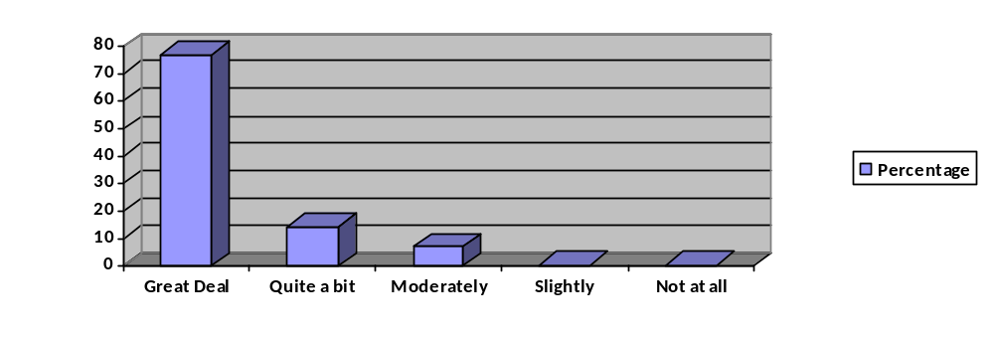
Figure 1: Comparison of increase in caring attitude of students for others

The percentages have been summarized in the table below:
 |  | Frequency | Percent | Valid Percent | Cumulative Percent
Valid | A great deal | 275 | 77.0 | 77.0 | 77.0
Valid | Quite a bit | 52 | 14.6 | 14.6 | 91.6
Valid | Moderately | 26 | 7.3 | 7.3 | 98.9
Valid | Slightly | 2 | .6 | .6 | 99.4
Valid | Not at all | 2 | .6 | .6 | 100.0
Valid | Total | 357 | 100.0 | 100.0

Table 1: Increase in caring attitude of students for others

ii) Increase in sense of usefulness and satisfaction of students

66.9 % of respondents gained a sense of usefulness and satisfaction after the completion of service learning projects. 27.5 % of them felt quite a bit, 5.1 % of them felt moderately, .3% of them felt slightly and .3% of them were not satisfied with it. Hence, a large majority of students felt that after the completion of the project they felt that they had achieved something great and they were totally satisfied with it. (The results are applicable to 356 respondents).
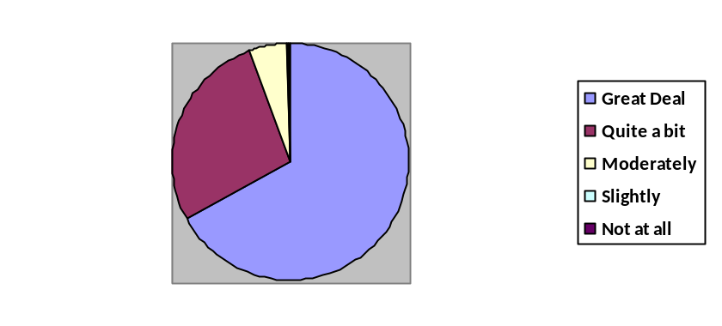
Figure 2: Increase in sense of usefulness and satisfaction of students
The frequency and percentage of results are presented below:

 |  | Frequency | Percent | Valid Percent | Cumulative Percent
Valid | A great deal | 238 | 66.7 | 66.9 | 66.9
Valid | Quite a bit | 98 | 27.5 | 27.5 | 94.4
Valid | Moderately | 18 | 5.0 | 5.1 | 99.4
Valid | Slightly | 1 | .3 | .3 | 99.7
Valid | Not at all | 1 | .3 | .3 | 100.0
Valid | Total | 356 | 99.7 | 100.0
Missing | System | 1 | .3
Total |  | 357 | 100.0
Table 2: Increase in sense of usefulness and satisfaction of students
iii) Students’ belief in becoming a better citizen
A large majority of students, that is; 79.8% believed that they had become better citizens after the implementation of their projects. 12.9% were quite a bit affected by it and 5.9% were moderately affected by its. Only 1.1% of them thought they slightly became better citizens while .3% of them were not at all affected by the outcome of the project. The results show that the service learning projects inculcated a sense of accomplishment among students and due to it, the students thought that they had become better citizens of the society. The results are summarized in the table below:

 |  | Frequency | Percent | Valid Percent | Cumulative Percent
Valid | A great deal | 285 | 79.8 | 79.8 | 79.8
Valid | Quite a bit | 46 | 12.9 | 12.9 | 92.7
Valid | Moderately | 21 | 5.9 | 5.9 | 98.6
Valid | Slightly | 4 | 1.1 | 1.1 | 99.7
Valid | Not at all | 1 | .3 | .3 | 100.0
Valid | Total | 357 | 100.0 | 100.0

Table 3: Students’ belief in becoming a better citizen

iv) Increase in students’ ability to work in teams

72.8% of the students thought that due to the service learning projects their ability to work in teams increased. 20.7% agreed to it quite a bit, 5% gained the moderate ability to do so, 1.1% believed that they slightly learned from the project to work in teams and only 0.3% believed that they did not learn from the project that how to work in teams. Therefore, we can say that a large majority of the respondents learned from the service learning projects, the ability to work in teams and were well satisfied with it. This shows the success of the implementation of the Service Learning Projects.
Slightly-1.1%
Moderately -5%
Quite a bit -20.7%
Great Deal -72.8%
Not at all 0.3%
Figure 3: Increase in students’ ability to work in teams

The results are summarized in the table below:

 |  | Frequency | Percent | Valid Percent | Cumulative Percent
Valid | A great deal | 260 | 72.8 | 72.8 | 72.8
Valid | Quite a bit | 74 | 20.7 | 20.7 | 93.6
Valid | Moderately | 18 | 5.0 | 5.0 | 98.6
Valid | Slightly | 4 | 1.1 | 1.1 | 99.7
Valid | Not at all | 1 | .3 | .3 | 100.0
Valid | Total | 357 | 100.0 | 100.0

Table 4: Percentages showing the increase in students’ ability to work in teams

v) Increase in concern for the welfare of others

Through the Service Learning Projects, the students’ increase in concern for the welfare of other increased a lot. 23.8% thought that it increase to some extent. 8.1% of the students found moderate improvement in their concern for other. 2% were slightly affected by it while 0.6% were not at all affected by it. Thus, majority of the students learned from the projects to work for the welfare of others. The results are summarized in the table below:

 |  | Frequency | Percent | Valid Percent | Cumulative Percent
Valid | A great deal | 234 | 65.5 | 65.5 | 65.5
Valid | Quite a bit | 85 | 23.8 | 23.8 | 89.4
Valid | Moderately | 29 | 8.1 | 8.1 | 97.5
Valid | Slightly | 7 | 2.0 | 2.0 | 99.4
Valid | Not at all | 2 | .6 | .6 | 100.0
Valid | Total | 357 | 100.0 | 100.0

Table 5: Results showing students’ increase in concern for the welfare of others

vi) Increase in sense of worth or self-esteem

Majority of the participants, that is; 58% found an increase in sense of worth or self-esteem after the completion of Service Learning Projects. 31.4% found their self-esteem to be increased to some extent, 5.3% found a moderate improvement in themselves while only 4.2% of them found only a slight improvement in them. Only about 0.3% of the students thought that the projects did not contribute in raising their self-esteem. Hence, it can be said that a majority of students believed that the completion of projects led them to think that they have accomplished something good in their life of which they are very proud of it.
The results are summarized in the table below:

 |  | Frequency | Percent | Valid Percent | Cumulative Percent
Valid | A great deal | 210 | 58.8 | 58.8 | 58.8
Valid | Quite a bit | 112 | 31.4 | 31.4 | 90.2
Valid | Moderately | 19 | 5.3 | 5.3 | 95.5
Valid | Slightly | 15 | 4.2 | 4.2 | 99.7
Valid | Not at all | 1 | .3 | .3 | 100.0
Valid | Total | 357 | 100.0 | 100.0

Table 6: Increase in sense of worth or self-esteem

vii) Increase in sense of purpose in life

66.1% of the students believed that due to the projects, their sense of purpose in life increased a lot. 24.6% found their sense of purpose in life increase quite a bit, 8.4% found a moderate increase in their sense of purpose, 0.6% found a slight increase in it, while about 0.3% found no increase at all. Hence, the Service Learning Projects contributed a lot in increasing the sense of purpose in the life of students. It gave direction to them in spending their lives for some good purpose. The results are summarized in the table below:

 |  | Frequency | Percent | Valid Percent | Cumulative Percent
Valid | A great deal | 236 | 66.1 | 66.1 | 66.1
Valid | Quite a bit | 88 | 24.6 | 24.6 | 90.8
Valid | Moderately | 30 | 8.4 | 8.4 | 99.2
Valid | Slightly | 2 | .6 | .6 | 99.7
Valid | Not at all | 1 | .3 | .3 | 100.0
Valid | Total | 357 | 100.0 | 100.0

Table 7: Increase in sense of purpose in life

viii) Increase in sense of personal achievement

66.7% of the students believed that they had achieved a sense of personal achievement to a great deal after the completion of these projects. 26.3% found an increase in sense of personal achievement quite a bit, 5.3% found a moderate increase in it, while only 1.7% found a slight increase in sense of achievement. None of the students believed that they had not achieved a sense of personal achievement due to the Service Learning Projects. Hence, the projects contributed a lot in raising a sense of personal achievement in students. They thought that due to it they have achieved something worth while in their lives.
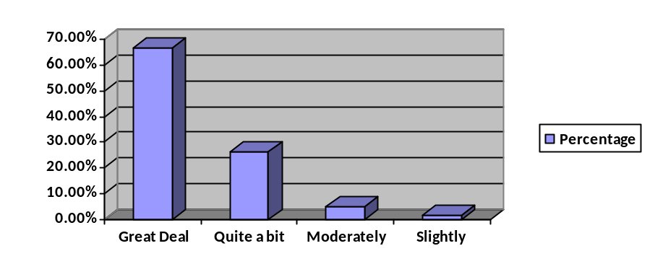
Figure 4: Increase in sense of personal achievement

The results are summarized in the table below:

 |  | Frequency | Percent | Valid Percent | Cumulative Percent
Valid | A great deal | 238 | 66.7 | 66.7 | 66.7
Valid | Quite a bit | 94 | 26.3 | 26.3 | 93.0
Valid | Moderately | 19 | 5.3 | 5.3 | 98.3
Valid | Slightly | 6 | 1.7 | 1.7 | 100.0
Valid | Total | 357 | 100.0 | 100.0

Table 8: Increase in sense of personal achievement

ix) Increase in basic academic skills

73.4% of students thought that they found an increase in their basic academic skills to a great deal. 19.3% thought that their basic academic skills increased quite a bit after accomplishing their projects. 6.7% of them believed that their academic skills increased moderately while only 0.6% believed that it improved slightly. Hence, the Service Learning Projects led to an increase in the basic academic skills of the students greatly. This shows the usefulness of the projects.
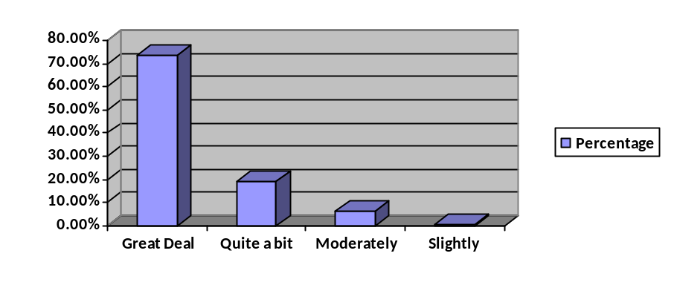
Figure 5: Increase in basic academic skills

The results are summarized in the table below:

 |  | Frequency | Percent | Valid Percent | Cumulative Percent
Valid | A great deal | 262 | 73.4 | 73.4 | 73.4
Valid | Quite a bit | 69 | 19.3 | 19.3 | 92.7
Valid | Moderately | 24 | 6.7 | 6.7 | 99.4
Valid | Slightly | 2 | .6 | .6 | 100.0
Valid | Total | 357 | 100.0 | 100.0

Table 9: Increase in basic academic skills

x) Increase in knowledge of the subject matter

When the students were inquired about the increase in knowledge of the subject matter related to the projects, it was found that 71.7% found a great deal of increase in the knowledge of the particular subject matter related to their projects. 22.4% found this increase quite a bit. 4.2% found a moderate increase in the subject matter while 1.4% a found a slight increase in their knowledge. Only 0.3% thought the projects did not contribute to the increase in knowledge of the subject matter related to their projects. Hence, overall the students learned a lot from their projects. The projects also helped them in learning things which were not included in their academic curriculums.
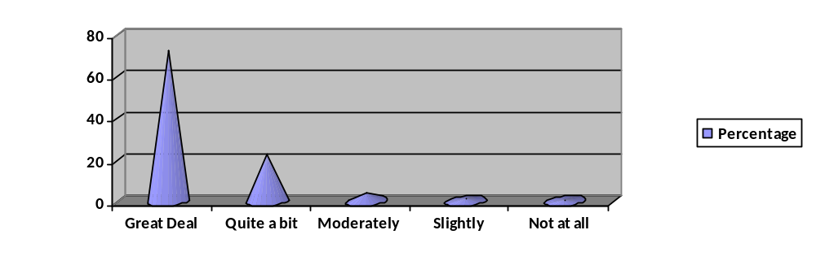
Figure 6: Increase in knowledge of the subject matter

The results are summarized in the table below:

 |  | Frequency | Percent | Valid Percent | Cumulative Percent
Valid | A great deal | 256 | 71.7 | 71.7 | 71.7
Valid | Quite a bit | 80 | 22.4 | 22.4 | 94.1
Valid | Moderately | 15 | 4.2 | 4.2 | 98.3
Valid | Slightly | 5 | 1.4 | 1.4 | 99.7
Valid | Not at all | 1 | .3 | .3 | 100.0
Valid | Total | 357 | 100.0 | 100.0

Table 10: Increase in knowledge of the subject matter

xi) Increase in the belief that students can make a difference

After completing the projects, 66.4% of the students believed that they can really make a difference by doing such projects. 24.6% of the students had a belief that they can make a difference to some extent, 6.7% of them thought that their contributions can make a difference to a moderate extent while only 2% thought that it can slightly make a difference. Only about 0.3% of the students thought that their contributions cannot make any difference at all. The projects raised a sense of achievement in students. It led them to think that by their contributions, they can really make a difference in society.
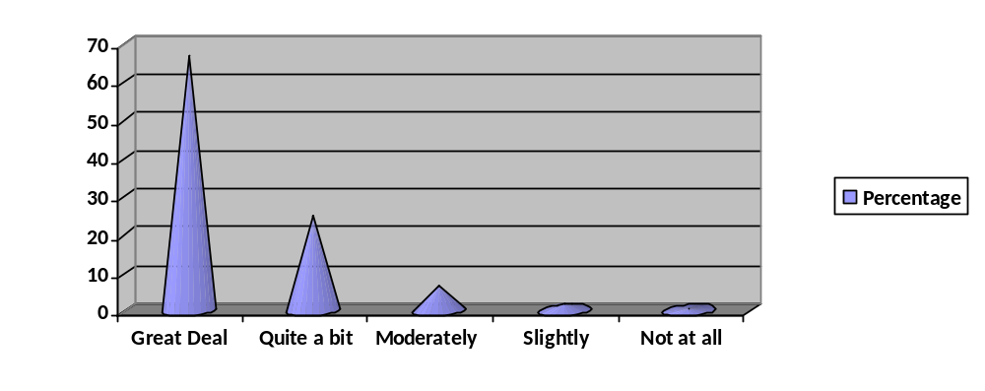
Figure 7: Increase in the belief that students can make a difference

The results are summarized below:

 |  | Frequency | Percent | Valid Percent | Cumulative Percent
Valid | A great deal | 237 | 66.4 | 66.4 | 66.4
Valid | Quite a bit | 88 | 24.6 | 24.6 | 91.0
Valid | Moderately | 24 | 6.7 | 6.7 | 97.8
Valid | Slightly | 7 | 2.0 | 2.0 | 99.7
Valid | Not at all | 1 | .3 | .3 | 100.0
Valid | Total | 357 | 100.0 | 100.0

Table 11: Increase in the belief that students can make a difference

xii) Increase in the sense of connectedness

About 54.3% of the students felt an increase in the sense of connectedness in them to a great deal due to these projects. 36.1% of them thought that their sense of connectedness had increased quite a bit, 8.1% thought that it increased to a moderate extent while only 1.1% thought that it increased to a slight extent. Just 0.3% of the students thought that the projects did not contribute at all in raising their sense of connectedness. Hence, a large majority of students felt a sense of connectedness in them due to the Service Learning Projects.

 |  | Frequency | Percent | Valid Percent | Cumulative Percent
Valid | A great deal | 194 | 54.3 | 54.3 | 54.3
Valid | Quite a bit | 129 | 36.1 | 36.1 | 90.5
Valid | Moderately | 29 | 8.1 | 8.1 | 98.6
Valid | Slightly | 4 | 1.1 | 1.1 | 99.7
Valid | Not at all | 1 | .3 | .3 | 100.0
Valid | Total | 357 | 100.0 | 100.0

Table 12: Increase in the sense of connectedness

xiii) Increase in the ability to apply knowledge gained in the classrooms

A large majority of students, that is; 72.8% thought that the implementation of the Service Learning Projects is the practical application of their knowledge gained in the classrooms. About 21.3% thought that they applied knowledge gained in the classroom to these projects quite a bit, 5% of them thought it has been applied moderately and only just 0.8% thought their knowledge was applied to a slight extent in these projects. None of the students thought that the projects did not apply the knowledge gained in the classrooms. Hence, this shows that through these projects, the students were able to see the practical application of what they had been taught. The results are summarized below:

 |  | Frequency | Percent | Valid Percent | Cumulative Percent
Valid | A great deal | 260 | 72.8 | 72.8 | 72.8
Valid | Quite a bit | 76 | 21.3 | 21.3 | 94.1
Valid | Moderately | 18 | 5.0 | 5.0 | 99.2
Valid | Slightly | 3 | .8 | .8 | 100.0
Valid | Total | 357 | 100.0 | 100.0

Table 13: Application of knowledge gained in the classrooms

xiv) Increase in improvement of relationship with the teachers

One of the best things about the Service Learning Projects is that it greatly increased the relationship of students with their teachers. A large majority of students, that is; 82.4% thought that their relationship with their teachers had increased to a great deal. Only 12% thought that it increased quite a bit, 3.6% thought that their relationship increased moderately and about 0.8% thought that it increased slightly. Just 1.1% of the students thought that their relationship with the teachers did not improve through these projects. The results have shown that it is the great achievement that these projects have improved relationship between students and teachers.
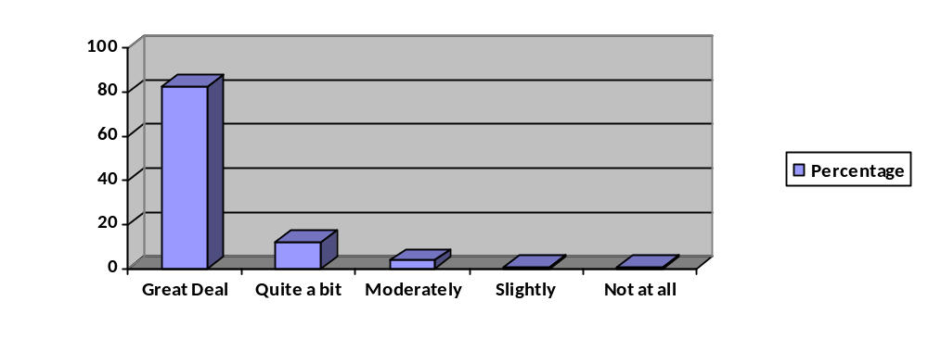
Figure 8: Increase in improvement of relationship with the teachers

The results are summarized in the table below:

 |  | Frequency | Percent | Valid Percent | Cumulative Percent
Valid | A great deal | 294 | 82.4 | 82.4 | 82.4
Valid | Quite a bit | 43 | 12.0 | 12.0 | 94.4
Valid | Moderately | 13 | 3.6 | 3.6 | 98.0
Valid | Slightly | 3 | .8 | .8 | 98.9
Valid | Not at all | 4 | 1.1 | 1.1 | 100.0
Valid | Total | 357 | 100.0 | 100.0

Table 14: Increase in improvement of relationship with the teachers

xv) Increase in improvement of relationship with other students

The Service Learning Projects contributed a lot in increasing the relationship of students with other students. About 73.9% of the students thought that their relationship with their class fellows increased to a great deal, 19.3% thought it to be increased to some extent and only 3.4% thought it to be increased moderately. Just 2.8% of the students believed that their relationship with other students increased slightly while only 0.6% thought that it did not improve at all. Hence, a large majority of students improved their relationships through these projects.
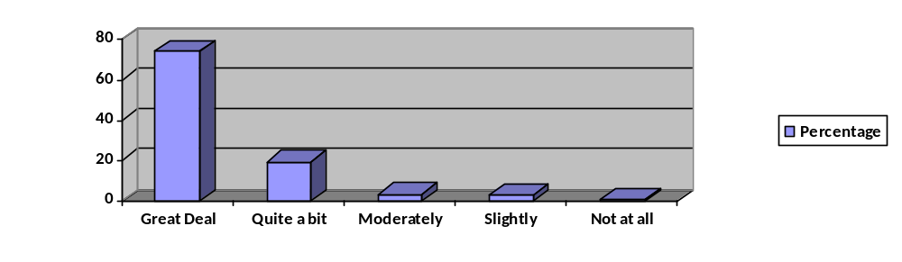
Figure 9: Increase in improvement of relationship with other students

The results are summarized in the table below:

 |  | Frequency | Percent | Valid Percent | Cumulative Percent
Valid | A great deal | 264 | 73.9 | 73.9 | 73.9
Valid | Quite a bit | 69 | 19.3 | 19.3 | 93.3
Valid | Moderately | 12 | 3.4 | 3.4 | 96.6
Valid | Slightly | 10 | 2.8 | 2.8 | 99.4
Valid | Not at all | 2 | .6 | .6 | 100.0
Valid | Total | 357 | 100.0 | 100.0

Table 15: Increase in improvement of relationship with other students

xvi) Enjoyment level of students while working on their projects

89.6% of the students had a great fun while working on their projects. 6.7% enjoyed quite a bit, 3.1% enjoyed moderately while 0.6% enjoyed a little bit. Overall, the students had a great experience while working on their projects. The results are summarized in the table below:

 |  | Frequency | Percent | Valid Percent | Cumulative Percent
Valid | A great deal | 320 | 89.6 | 89.6 | 89.6
Valid | Quite a bit | 24 | 6.7 | 6.7 | 96.4
Valid | Moderately | 11 | 3.1 | 3.1 | 99.4
Valid | Slightly | 2 | .6 | .6 | 100.0
Valid | Total | 357 | 100.0 | 100.0

Table 16: Enjoyment level of students while working on their projects

xvii) Interest of students in doing more projects

A large majority of students, that is; 78.9% were interested in doing more projects of Service Learning. 9.8% of students were interested quite a bit in doing another project, 7.6% were moderately interested while 2.2% were just slightly interested in doing so. Only about 1.4% of the students were not at all interested in doing another project. (The results are applicable to 356 students). The Service Learning Projects left a very good impact on students. These projects helped the students not only in their self development but also in the welfare of their fellow beings. The results are summarized in the table below:

 |  | Frequency | Percent | Valid Percent | Cumulative Percent
Valid | A great deal | 281 | 78.7 | 78.9 | 78.9
Valid | Quite a bit | 35 | 9.8 | 9.8 | 88.8
Valid | Moderately | 27 | 7.6 | 7.6 | 96.3
Valid | Slightly | 8 | 2.2 | 2.2 | 98.6
Valid | Not at all | 5 | 1.4 | 1.4 | 100.0
Valid | Total | 356 | 99.7 | 100.0
Missing | System | 1 | .3
Total |  | 357 | 100.0

Table 17: Interest of students in doing more projects

b) Analysis of views of teachers

i) Performance of students in the Service Learning Projects

71.2% teachers thought that the quality of serving learning projects made by students were excellent while 28.8% think that they were good. Thus the satisfaction level of teachers about the performance of students is high. 57.6% teachers thought that students’ willingness to work on projects were excellent while the rest of them (42.4%) thought that it was good. The students found it interesting to work on Service Learning projects. 59.1% teachers thought that the cooperative attitudes of students were excellent while 40.9 % thought that it was good. Thus, overall the students cooperated a lot with teachers while working on their projects.

48.5% of the teachers thought that the acceptance of supervision by the students was excellent while 50% thought that it was good. Only 1.5% of them thought that it was poor. Majority of the students willingly accepted the supervision of their projects. 47% of teachers thought that the students were excellent in taking initiative, while 53% thought that the students were good in taking initiatives during project work. This shows that the students had the leadership ability and confidence to take necessary action required for their project work. 48.5% of the teachers thought that the students were very courteous during their project work while 51.5% thought that they were good at being courteous to others. Hence, the students behaved very well while working on their projects as they were well mannered and considerate. According to 36.4% of the teachers, the dependability level of the students was high, while 62.1 thought that it was moderate. Hence, the students were dependent upon each other and on teachers to some extent. Only 1.5% thought that the dependability level of students was poor. 54.5% of the teachers believed that the project helped a lot in the personal grooming of the students to a great extent. 45.5% thought that the personal grooming of students occurred quite a bit. The projects helped a lot in the self development of the students. According to 33.3% of the teachers, the students’ punctuality and attendance rating was excellent while 66.7% thought that it was good.
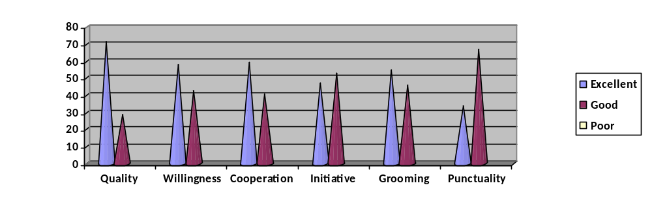
Figure 10: Performance of students in the Service Learning Projects

Hence, overall the students’ performance was rated quite satisfactory by the teachers. The students showed improvements in their behaviors and attitudes while accomplishing these projects. The rating of the students is summarized in the table below:

Quality of Serving Learning
 |  | Frequency | Percent | Valid Percent | Cumulative Percent
Valid | excellent | 47 | 71.2 | 71.2 | 71.2
Valid | good | 19 | 28.8 | 28.8 | 100.0
Valid | Total | 66 | 100.0 | 100.0
Willingness to work
 |  | Frequency | Percent | Valid Percent | Cumulative Percent
Valid | excellent | 38 | 57.6 | 57.6 | 57.6
Valid | good | 28 | 42.4 | 42.4 | 100.0
Valid | Total | 66 | 100.0 | 100.0
Cooperative attitude
 |  | Frequency | Percent | Valid Percent | Cumulative Percent
Valid | excellent | 39 | 59.1 | 59.1 | 59.1
Valid | good | 27 | 40.9 | 40.9 | 100.0
Valid | Total | 66 | 100.0 | 100.0

Works well with others
 |  | Frequency | Percent | Valid Percent | Cumulative Percent
Valid | excellent | 32 | 48.5 | 48.5 | 48.5
Valid | good | 33 | 50.0 | 50.0 | 98.5
Valid | poor | 1 | 1.5 | 1.5 | 100.0
Valid | Total | 66 | 100.0 | 100.0

Acceptance of Supervision
 |  | Frequency | Percent | Valid Percent | Cumulative Percent
Valid | excellent | 32 | 48.5 | 48.5 | 48.5
Valid | good | 33 | 50.0 | 50.0 | 98.5
Valid | poor | 1 | 1.5 | 1.5 | 100.0
Valid | Total | 66 | 100.0 | 100.0

Takes Initiative
 |  | Frequency | Percent | Valid Percent | Cumulative Percent
Valid | excellent | 31 | 47.0 | 47.0 | 47.0
Valid | good | 35 | 53.0 | 53.0 | 100.0
Valid | Total | 66 | 100.0 | 100.0

Courtesy
 |  | Frequency | Percent | Valid Percent | Cumulative Percent
Valid | excellent | 32 | 48.5 | 48.5 | 48.5
 | good | 34 | 51.5 | 51.5 | 100.0
 | Total | 66 | 100.0 | 100.0

Dependability
 |  | Frequency | Percent | Valid Percent | Cumulative Percent
Valid | excellent | 24 | 36.4 | 36.4 | 36.4
Valid | good | 41 | 62.1 | 62.1 | 98.5
Valid | poor | 1 | 1.5 | 1.5 | 100.0
Valid | Total | 66 | 100.0 | 100.0
Personal Grooming

 |  | Frequency | Percent | Valid Percent | Cumulative Percent
Valid | excellent | 36 | 54.5 | 54.5 | 54.5
Valid | good | 30 | 45.5 | 45.5 | 100.0
Valid | Total | 66 | 100.0 | 100.0

Punctuality and Attendance
(Did the students call if late or absent?)
 |  | Frequency | Percent | Valid Percent | Cumulative Percent
Valid | excellent | 22 | 33.3 | 33.3 | 33.3
Valid | good | 44 | 66.7 | 66.7 | 100.0
Valid | Total | 66 | 100.0 | 100.0

Table 18: Performance of students in the Service Learning Projects

ii) Opinion of teachers about service learning and its effects on students and on themselves

A large majority of teachers that is; 78.5% strongly agreed that Service Learning is the most effective strategy for students’ development, while 21.2% of them agreed to it to some extent. Therefore, a great majority of them believed that the best strategy to improve the self development of students is through Service Learning. 66.7% of the teachers strongly agreed that Service Learning improves the academic performance of students. 33.3% of them agreed to some extent. This view is in accordance with the views of the students in which 73.4% of them strongly agreed that the Service Learning Projects contributed a lot in the increase in their basic academic skills and knowledge. None of the students disagreed with it.
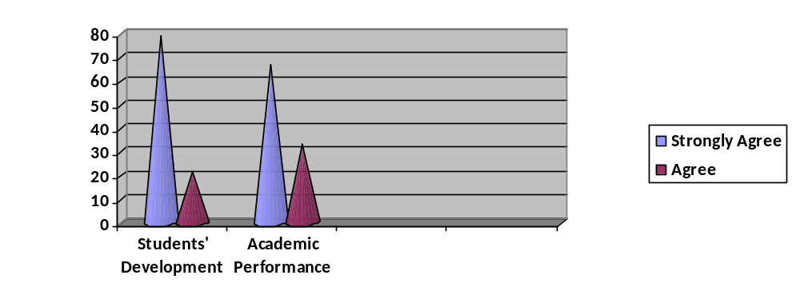
Figure 11: Effects of Service Learning on Students

The results are summarized in the table below:

Service Learning is the most effective strategy for students’ development
 |  | Frequency | Percent | Valid Percent | Cumulative Percent
Valid | strongly agree | 52 | 78.8 | 78.8 | 78.8
Valid | agree | 14 | 21.2 | 21.2 | 100.0
Valid | Total | 66 | 100.0 | 100.0

Service Learning improves the academic performance of the students
 |  | Frequency | Percent | Valid Percent | Cumulative Percent
Valid | strongly agree | 44 | 66.7 | 66.7 | 66.7
Valid | agree | 22 | 33.3 | 33.3 | 100.0
Valid | Total | 66 | 100.0 | 100.0

Table 19: Effects of Service Learning on Students

When teachers were inquired about the effects of Service Learning on themselves they informed that it contributed a lot in increasing their knowledge and skills. 74.2% of the teachers strongly agreed that its enhanced their knowledge to a great deal while 25.8% agreed to some extent that it led to the increase in their knowledge and skills. Hence, not only the students were benefitted by the Service Learning Projects but also the students.

A large majority of teacher that is; 89.4% strongly agreed that Service Learning Projects had increased their relationship with the students to a great deal. The rest of the 10.6% also agreed to it to some extent. This opinion of teachers is also in accordance with the views of the students in which 82.4% of them agreed to a great deal that their relationship with the teachers had become strong. This is one of the best thing about the Service Learning Projects as usually students have a fear of or are shy of communicating with their teachers.

60.6% of the teachers thought that they had fulfilled the Service Learning objectives to a great deal while about 39.4% of them thought that they fulfilled it to some extent. None of them disagreed with it. Hence, the Service Learning projects also raised a sense of accomplishments in teachers.

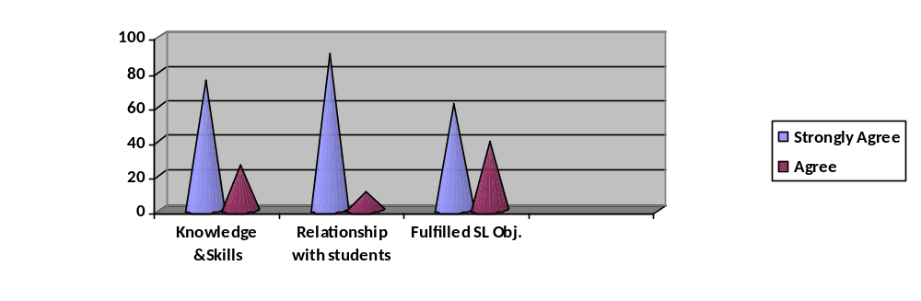
Figure 12: Effects of Service Learning on Teachers

Service Learning has enhanced my knowledge and skills
 |  | Frequency | Percent | Valid Percent | Cumulative Percent
Valid | strongly agree | 49 | 74.2 | 74.2 | 74.2
Valid | agree | 17 | 25.8 | 25.8 | 100.0
Valid | Total | 66 | 100.0 | 100.0

Service Learning has improved my relationship with students
 |  | Frequency | Percent | Valid Percent | Cumulative Percent
Valid | strongly agree | 59 | 89.4 | 89.4 | 89.4
Valid | agree | 7 | 10.6 | 10.6 | 100.0
Valid | Total | 66 | 100.0 | 100.0

q15
I have fulfilled Service Learning Objectives
 |  | Frequency | Percent | Valid Percent | Cumulative Percent
Valid | strongly agree | 40 | 60.6 | 60.6 | 60.6
Valid | agree | 26 | 39.4 | 39.4 | 100.0
Valid | Total | 66 | 100.0 | 100.0

Table 20: Effects of Service Learning on Teachers

iii) Greatest challenge faced by the teachers

57.9% of the teachers thought that the greatest challenge faced by the teachers in implementing Service Learning Projects was to engage the students in practical work. Teachers had to work hard a lot in arranging brain storming sessions for students, organizing teams, assigning tasks and responsibilities to teams and maintaining continuous communication with the students and their parents. According to 31.6% of the teachers, the greatest challenge faced by them was to start the project. Starting the project requires leadership abilities, taking initiatives and good communication and management skills. 8.8% of the teachers believed that the greatest challenge was to adopt a passive job in the execution of the project. The teachers had to wait and observe the strategy adopted by the students to implement the projects. They had to make the students active in implementing their own ideas. Only 1.8% of the teachers thought that the biggest challenge faced by them was to engage the students in practical work and to adopt a passive job in the execution of the projects. (The results of these views are applicable to only 57 respondents). As it was a first time experience of the teachers for involving students in the Service Learning Projects, they found it quite challenging and interesting to do so.
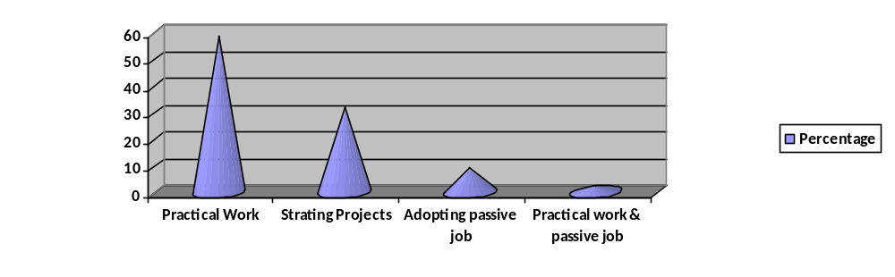
Figure 13: Challenges faced by teachers in Service Learning Projects

The results are summarized in the table below:

 |  | Frequency | Percent | Valid Percent | Cumulative Percent
Valid | to start the project | 18 | 27.3 | 31.6 | 31.6
Valid | engage students in practical work | 33 | 50.0 | 57.9 | 89.5
Valid | adopt passive job execution of project | 5 | 7.6 | 8.8 | 98.2
Valid | 23 | 1 | 1.5 | 1.8 | 100.0
Valid | Total | 57 | 86.4 | 100.0
Missing | System | 9 | 13.6
Total |  | 66 | 100.0

Table 21: Challenges faced by teachers in Service Learning Projects

Findings from the survey of impact of Service Learning projects on students and teachers of top 6 Catholic Schools in Lahore

The survey results have shown that majority of the students’ attitudes had been changed after the implementation of these projects. They had become more caring, courteous and concerned about others. A large majority of students felt that after the completion of the project they felt that they had achieved something great and they were totally satisfied with it. These projects inculcated a sense of accomplishment among students and made them to think that they had become better citizens of the society. Majority of the students learned from the projects that how to work for the welfare of others and how to work together in teams.

The students believed that the completion of projects led them to think that they had accomplished something good in their life and they were really proud of it. The Service Learning Projects contributed a lot in increasing the sense of purpose in the life of students. It gave direction to them in spending their lives for some good purpose. None a single student believed that they had not achieved a sense of personal achievement due to the Service Learning Projects. Therefore, the projects contributed a lot in raising a sense of personal achievement in students.

The Service Learning Projects led to an increase in the basic academic skills of the students greatly. Overall the students learned a lot from their projects. These projects helped them in learning things which were not included in their academic curriculums. None of the students thought that the projects did not apply the knowledge gained in the classrooms. Hence, this shows that through these projects, the students were able to see the practical application of what they had been taught.

A large majority of students felt a sense of connectedness in them due to the Service Learning Projects. It is s a great achievement that these projects had improved relationship between students and teachers. These projects helped the students not only in their self development but also in the welfare of their fellow beings. The students behaved very well while working on their projects as they were well mannered and considerate. The projects helped a lot in the self grooming of the students. Both the students and the teachers believed that the Service Learning Projects contributed a lot in improving their relationship with each other.

According to the teachers, the students showed improvements in their behaviors and attitudes while accomplishing these projects. A great majority of them believed that the best strategy to improve the self development of students is through Service Learning. Service Learning Projects contributed a lot in the increase in their basic academic skills and knowledge of students.

When teachers were inquired about the effects of Service Learning on themselves they informed that it contributed a lot in increasing their knowledge and skills. Hence, not only the students were benefitted by the Service Learning Projects but also the teachers. Service Learning projects also raised a sense of accomplishments in teachers. The biggest challenges faced by the teachers were to engage the students in practical work and staring a project. The teacher believed that they did their part in fulfilling the Service Learning Objectives.

Hence, the survey has shown that the Service Learning Projects were mutually beneficial for the students and the teachers and created a positive effect on the community. Such projects inculcates academic learning, life skills, leadership skills, communication skills, management skills, self esteem and self confidence in students and helps them in their self development and self grooming of students. It develops a sense of caring attitude and a sense of responsibility in students and improves their relationship with other fellow beings. The teachers also increase their knowledge through it while working with the students. It improves their relationship with the students and they get a better understanding of the feelings of their students.

Questionnaire for students related to the survey of the impact of Service Learning projects on students and teachers of top 6 Catholic Schools in Lahore
Student Questionnaire/Survey
Name of the Student:
Age Group: A: 5-8 B: 9-12 C: 13-16
Class:
School:
Gender:
Using the scale below please indicate the degree to which participation in this course has increased or strengthened your:
 | A great deal | Quite a bit | Moderately | Slightly | Not at all
- Skills in caring for others
- Sense of usefulness and satisfaction
- Belief in becoming a better citizen
- Ability to work or relate with others
- Concern for the welfare of others
- Sense of worth or self-esteem
- Sense of purpose in life
- Sense of personal achievement
- Your basic academic skills
- Knowledge of the subject matter
- Belief that you can make a difference
- Sense of connectedness
- Ability to apply knowledge gained in classroom
- Improve relationship with teacher
- Improve relationship with other students
- Was fun to work on the project
- Interest in doing another project

Thank you!

Questionnaire for teachers related to the survey of the impact of Service Learning projects on students and teachers of top 6 Catholic Schools in Lahore
Teacher Questionnaire/Survey
Name: ____________________
Age: ______________________
Class: _____________________
School: ____________________

Students Performance  Rating | Excellent | Good | Poor
Quality of Service learning
Willingness to work
Cooperative attitude
Works well with others
Acceptance of supervision
Takes attitude
Courtesy
dependability
Personal grooming
Punctuality and attendance.
(Did the student call it if late or absent)

Please tick the right one:

Indicators | Strongly agree | Agree | Disagree
Service Learning is the most effective strategy for students’ development.
Service Learning improves academic performance of the students.
Service Learning has enhanced my knowledge and skills.
Service Learning has improves my relationship with students.
I have fulfilled service learning objectives.

The greatest challenge in my assignment was:
- To start the project
- to engage the students in practical work
- To adopt a passive job in the execution of the project
- Others_____________________________________

Thank you!

